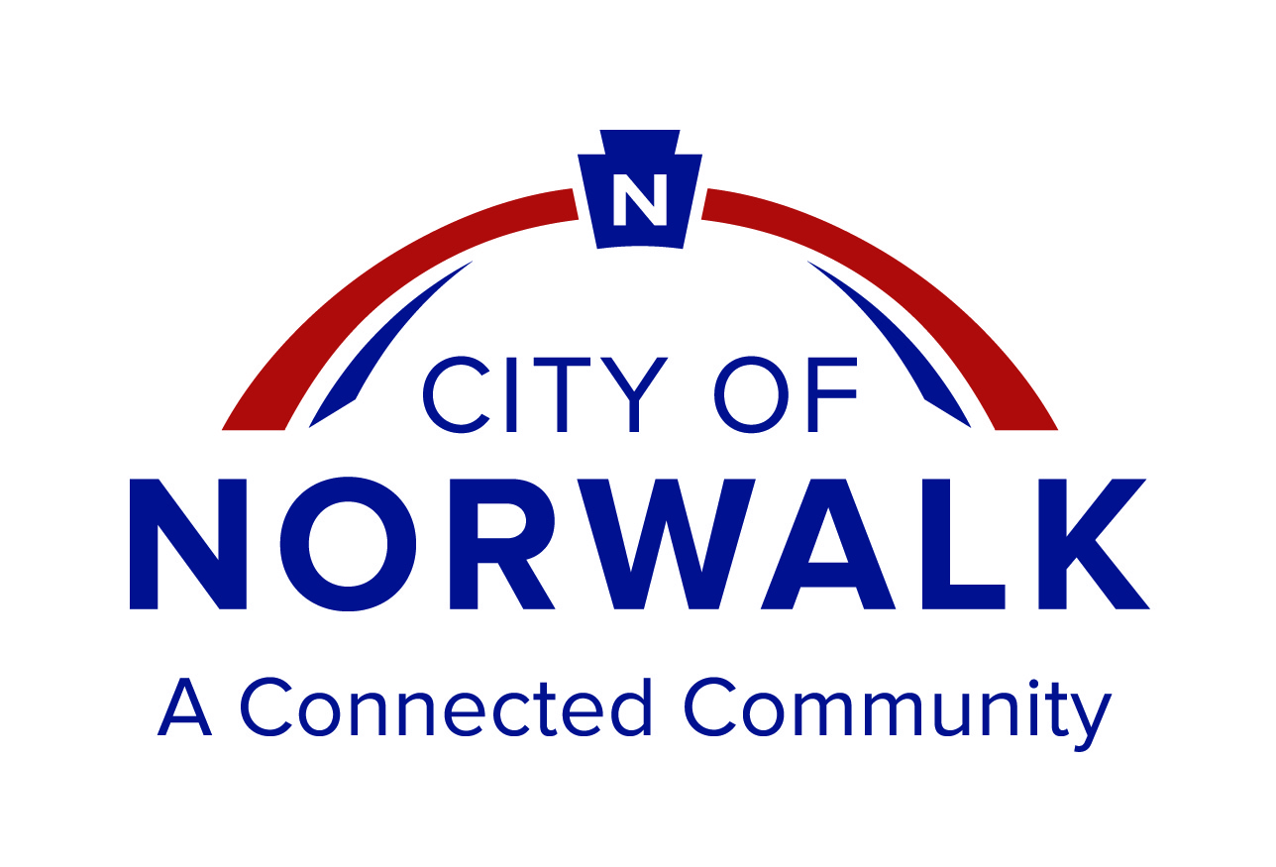

Norwalk Senior Center

VOLUNTEER APPLICATION
14040 San Antonio Drive, Norwalk, CA, 90650
(562) 929-5580

TODAY’S DATE: ____________________________________ 2022
Please Print

NAME _______________________________________________ DATE OF BIRTH_________________________

Last First
TELEPHONE: Home: ________________________ Cell: __________________________ I Live Alone: □ Yes □ No

STREET ADDRESS _____________________________________________________________________________________

City and Zip Code __________________________________________________________________________________

E-Mail Address: ________________________________________________________________________________________

CHECK INTERESTS IN VOLUNTEER POSITIONS
□ Bingo □ Nutrition Program □ Special Events □ Senior Center Garden
□ Instructors (Please specify) __________________________________________________
□ Student Intern (Please specify school, number of hours, date hours to be completed by) ______________________________
_________________________________________________________________________________________________________________
□ Other (Please specify) __________________________________________________________________

FORMER PROFESSION:_______________________________________________________________________________________
SKILLS/ABILITIES:_____________________________________________________________________________________________
INTEREST:______________________________________________________________________________________________________
LANGUAGES SPOKEN (besides English): ____________________________________________________________________

AVAILABILITY Please circle days: Mon. / Tues. / Wed. / Thurs. / Fri. / Sat.
Time available: _______________________________________________________________

EMERGENCY CONTACT INFORMATION:

Name _______________________________________________________________________

Relationship ________________________________ Cell Phone ________________________________

Name _______________________________________________________________________

Relationship _________________________________ Cell Phone _____________________________

ACKNOWLEDGEMENT: I acknowledge, understand, and agree that the information contained on this form may be released, by the City for statistical purposes, and I agree to the City’s release of the information for that limited purposed only. I understand that the City may not release any personally identifiable information contained on this form without my advance written consent and that the City will not use the information on this form to determine my eligibility to participate in the program offered by the City nor will the information affect my ability to participate in the program unless a local, state, or federal law specifically restricts program participation based on the information contained on this form.

Participant Release, Hold Harmless, and Indemnification Agreement

ACKNOWLEDGEMENT OF RISKS I __________________________________ (name) acknowledge that I have voluntarily chosen to participate in a program offered by the City of Norwalk at the Norwalk Senior Center. I acknowledge that my participation in the program is or may be dangerous and will or may involve strenuous physical activity and/or risks of injury, loss, or damage to myself. I further acknowledge that these risks may include, without limitation, bodily injury, personal injury, sickness, including exposure to COVID-19, disease, death, and property loss or damage.

EXPRESS ASSUMPTION OF RISKS AND RESPONSIBILITY By signing this section of the document, I knowingly, voluntarily, and freely assume all risks, whether foreseen or unforeseen, in participation in the program, even if arising from the active or passive negligence of the City or others, and assume full responsibility for my participation in the program.

COMPLIANCE WITH TERMS AND CONDITIONS I willingly agree to comply with any stated and customary terms and conditions and any COVID-19 related policies required for participation in the program. If, however, I observe any unusual significant hazard during my presence at the Norwalk Senior Center or my participation in the program, I will remove myself from the hazardous situation and bring it to the attention of City and/or Senior Center Facility staff.

INDEMNIFICATION AND HOLD HARMLESS In consideration for the right to participate in the program, and to the fullest extent permitted by law, I, for myself, my heirs, executors, personal representatives, administrators, assigns, and next of kin, hereby indemnify and hold harmless the City, and its respective officials, officers, agents, volunteers and employees ("Indemnitees"), from and against any and all claims, demands, causes of action, costs, expenses, liabilities, losses, damages or injuries, in law or equity, to property or persons, including, without limitation, wrongful death, that arise out of, pertain to, or are incident to my participation in the program, whether arising from the active or passive negligence Indemnitees or otherwise.

RELEASE In consideration for the right to participate in the program, and to the fullest extent permitted by law, I, for myself, my heirs, executors, personal representatives, administrators, assigns, and next of kin hereby release, discharge, and agree not to sue the City, and its respective officials, officers, agents, volunteers, instructors, and employees, and other organizations participating or involved in providing or promoting classes, functions, programs, testing, or other activities that I participate in, at the Norwalk Senior Center, and their respective including owners, officials, officers, directors, employees, agents, volunteers, and representatives (collectively, “Releases”), with respect to any and all injury, disability, sickness including COVID-19, death, loss or damage to person or property, demands, or liabilities, that arise out of, pertain to, or are incident to my participation in the program, whether arising from the active or passive negligence of Releases or otherwise.

I HAVE READ THIS RELEASE, HOLD HARMLESS, AND INDEMNIFICATION AGREEMENT, FULLY UNDERSTAND ITS TERMS, UNDERSTAND THAT I HAVE GIVEN UP SUBSTANTIAL RIGHTS BY SIGNING IT, AND SIGN IT FREELY AND VOLUNTARILY WITHOUT INDUCEMENT

I have also read, understand, and will adhere to all program guidelines and I may withdraw from the program at any time and/or the City may withdraw me from the program if I am absent for three (3) consecutive weeks.

I understand that I may be photographed or videotaped. I agree to allow my photo, video or film likeness to be used for any legitimate purpose by the City. _________ (INITIAL)

Signature____________________________________________________ Date_________________

For Office Use

Interviewed by _______________________ Interview Date______________________________

Position Placed_______________________ Date Placed________________________________

Days and Time committed to___________________________________________________________

Staff Comments: _____________________________________________________________________

____________________________________________________________________________________

